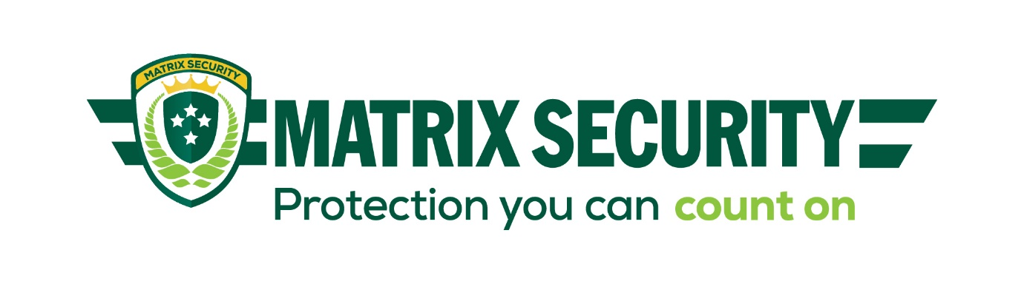
PHYSICAL SECURITY AUDIT CHECKLIST

Culture and Business
 | Yes | No | Risk | Comment | Action
Is a documented workplace security policy in place?
Have you communicated your policies and procedures to your employees, suppliers and other stakeholders who can impact your security efforts?
Do you provide regular training to keep your employees up to date with best practice?
Do you reward and recognise people who do the right thing for security in your business?
Do you regularly review the security risks to your business?
Do you have assets that are valuable to criminals?
Do you have traffic flow in and out of the business?
Do you operate outside of standard business hours?

Neighbourhood
 | Yes | No | Risk | Comment | Action
Do you have any businesses that operate 24 hours within near vicinity?
Do your neighbours have well maintained properties (consider the presence of rubbish, graffiti, signage)?
Do you have a good relationship with your neighbours?
Do your neighbours have obvious security in place (video surveillance, alarms, security guards, patrols, signage etc)

Exterior
 | Yes | No | Risk | Comment | Action
Is there clear signage identifying your business, entry and exit points, restricted areas and parking?
Does the landscaping offer locations to hide or means of access to rooftops?
Are all entrance points to your building monitored?
Do you regularly scout the exterior of your building (including the boundary) for any damage?
Are there floodlights to illuminate blind spots so security officers, employees and others can see places of possible concealment or access?
Do you have sensor lights at entry points?
Can you see any valuable assets from external points?
Do you have gates that are secure, operating properly and regularly maintained?
Do you have fences tall enough to reduce unauthorised access? Is the fence checked regularly for holes and/or damage?
Are windows protected with grills and/or bars?
Do you have good quality security company signage in well-lit and visible areas?
Do you have video surveillance?
Is the video monitored, verified or recordings stored securely?

Interior
 | Yes | No | Risk | Comment | Action
Is access to the building and/or specific areas inside restricted?
Are all access points monitored?
Is ID based access control in place?
Do you maintain a visitor register?
Are employees easily identifiable?
Do you regularly check all security systems you have, including ensuring employees have the correct levels of access?
Is an alarm system installed and maintained?
Is the alarm system monitored?
Is the building monitored for fire or smoke?
In the event of a forced entry/alarm activation, have you a documented process in place? Is this regularly reviewed?
Do you have a backup solution for your alarm in the event there is an internet or power outage?
Do you receive regular activity reports from your supplier?
Do you have video surveillance?
Is the video monitored, verified or recordings stored securely?
Is a master key locking system in place?

